IOT based Streetlight monitoring and controlling system

*Pratham Patel Information Technology Department, CSPIT Changa [20it105@charusat.edu.org](mailto:20it105@charusat.edu.org)

**Parth Shah Information Technology Department, CSPIT Changa [parthshah.ce@charusat.ac.in](mailto:parthshah.ce@charusat.ac.in)

***Abstract:***

*A Street light, lamppost, street lamp is a source of light on the road or walkaway, which is turned on at a certain time .The major advantages of street lighting is prevention of accidents and increase in safety. The aim of IOT based Street light monitoring and controlling system is to stop the wastage of electricity as well as to provide a safe environment. Street light consumes a large proportion of electricity. so, that can be avoided using IOT based Streetlight monitoring and controlling system. It works like If you walk at the night the light intensity will be high and in the morning falls to the minimum.*

*This street lighting is one of the largest energy cost of a city. A street lighting system can cut municipal street lighting cost is 50% to 70%.*

***Keywords****:* Internet of things (IOT) , Street lights , light intensity .

## **Introduction**

The Internet of Things (IoT) is a system of physical things fixed with sensors, software, electronics and connectivity to allow it to perform better by exchanging information with other connected devices, the operator or the manufacturer. IOT is the network of physical devices that allows the devices to communicate with each other and IOT allows

remote sensing and control over the devices. It is an advanced automation and problem-solving system which uses artificial intelligence technology to deliver advanced and automated products and services. These systems allow transparency, control, and good performance. IOT has several automation applications like smart home, smart parking, Smart Hotel Rooms, smart lighting, etc. The current manual streetlight system has many problems like maintenance issues, timing problem, and connectivity issues. These problems can be solved by IOT technology. This new system is a result of Thinking about the huge power consumption of the present lighting system that consume over world’s 79.3% of electricity and also the human intervention. This IOT based Street light monitoring and controlling is a project on smart and automated light control to control the problem of power consumption and usage of the streets manually, late in the night. The main motive of the system is the energy conservation because the resources like hydro, coal that we rely upon are not easily restored, so introducing power saving elements like LDR Relays can light up a large area with high-intensity light whenever needed. IOT based street light automation is used to stop the wastage of electricity as well as to provide a safe environment method which also eliminates the problems in disposal of incandescent lamps and power saving .

**IOT based Streetlight monitoring and controlling system:**

Street Light Monitoring & control is an automated system designed for increase the efficiency and accuracy of industry by automatically timed controlled switching of street lights .This project identifies the new streetlights. This project describes a new economical solution for the street light control system. In that street light intensity gets changed along with the environment . If you walk at night the light intensity will be high and in the morning falls to the minimum. This data is monetarized by online system in that it showing the unit consumes.

## **Hardware Interfaces :**

1. LDR : An LDR is a type of variable resistor which changes its resistance according to the intensity of the light falling on its surface.



Fig. 1 LDR

1. 100K PRESET : Preset 100K Ω (ohm) (Variable Resistance) This adjustable or Variable resistor are PCB mountable and has 3 terminals. The voltagle between the terminal varies as the preset (Variable Resistance)is rotated.



Fig. 2 100K PRESET

1. BT 136 TRIAC : The BT136 is TRIAC with 4A maximum terminal current. The gate threshold voltage of the BT136 TRIAC is also very less so can be driven by digital circuits. Since TRIACs are bi-directional switching devices they are commonly used for switching AC application.

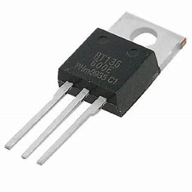

Fig. 3 BT136 TRIAC

1. BC 547 TRANSISTOR : **BC547** is a NPN**transistor** hence the collector and emitter will be left open when the base pin is held at ground and it will be closed when a signal is provided to base pin.

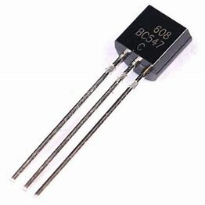

Fig. 4 BC547 TRANSISTOR

1. 220 OHMS RESISTOR *2 : 220 ohm ¼ watt Resistor (Pack of 10) A resistor is a passive electrical component that implements electrical resistance as a circuit element. Resistors reduce current flow and at the same time, act to lower voltage levels within circuits.

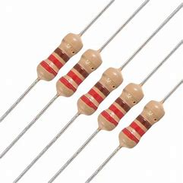

Fig. 5 220 OHMS RESISTOR

## **Software Interfaces**

1. Programming Language C
2. Arduino Online Compiler

## **Working Model**

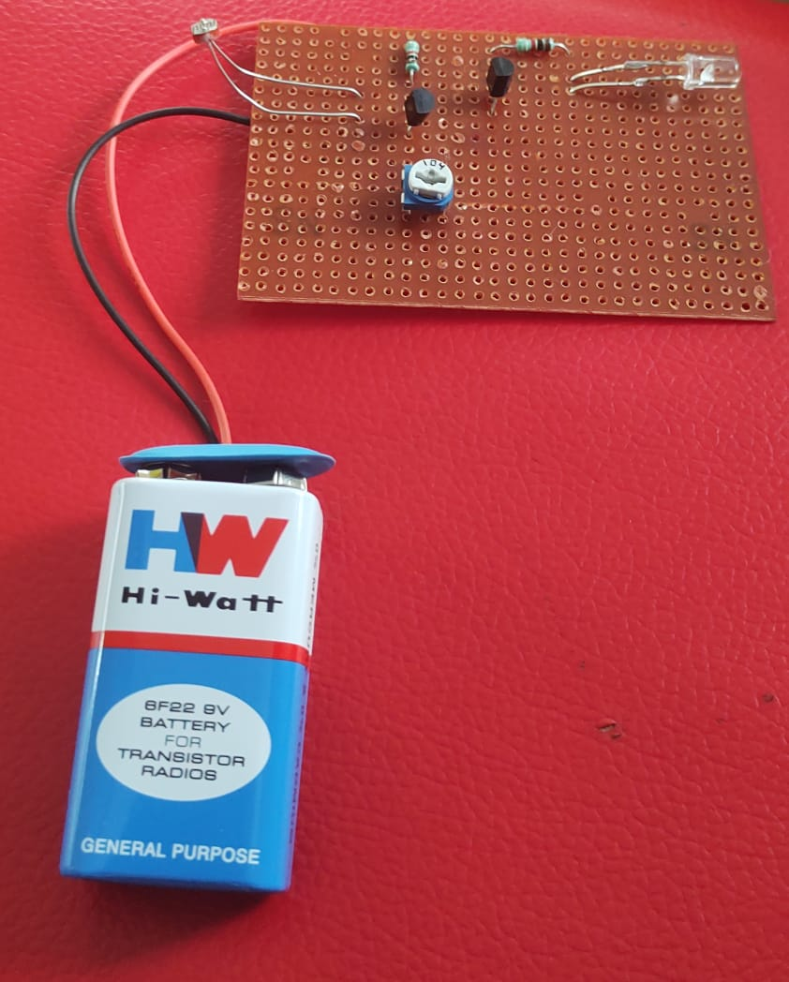

Fig. 6 Working Model

**Flowchart:**

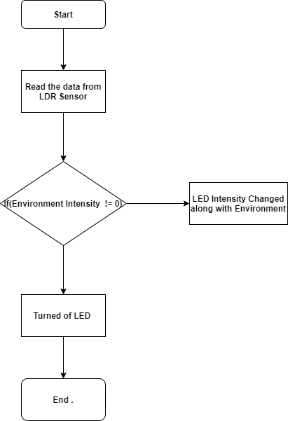

* IOT based Streetlight monitoring and controlling system This data is monetarized by online system in that it showing the unit consumes, consumption Prediction This System looks like Fig.7 .

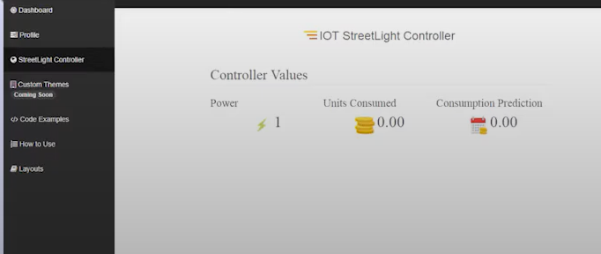

Fig. 7 Onlie System

## **Conclusion**

In this paper, a self-sufficient street lighting control and monitoring system based on the wireless technology. The main reason for carrying out this project is an energy saving. A street lighting system can cut municipal street lighting cost is 50% to 70%.

## **References**

1. Smart Street Lighting Control and Monitoring System for Electrical Power Saving by Using VANET, Samir A. Elsagheer Mohamed,College of Computer, Qassim University, Buryadah, KSA, Int. J. Communications, Network and System Sciences, 2013, 6, 351-360.
2. www.mavensystem.com/lighting automation
3. Cloud based automatic street light monitoring system.
4. [Streetlight Monitoring System IOT Project - ProjectsGeek](https://projectsgeek.com/2018/02/streetlight-monitoring-system-iot-project.html)
5. Optimization of standalone street light system with consideration of lighting control.
6. Optimization of standalone street light system with consideration of lighting control.
7. [Automated street lighting system using IoT (ijariit.com)](https://www.ijariit.com/manuscripts/v4i3/V4I3-1830.pdf)
8. Design of new intelligent street light control system
9. [IoT Based Automatic Electronic System for Monitoring and Control of Street Lighting | IEEE Conference Publication | IEEE Xplore](https://ieeexplore.ieee.org/document/9292246)